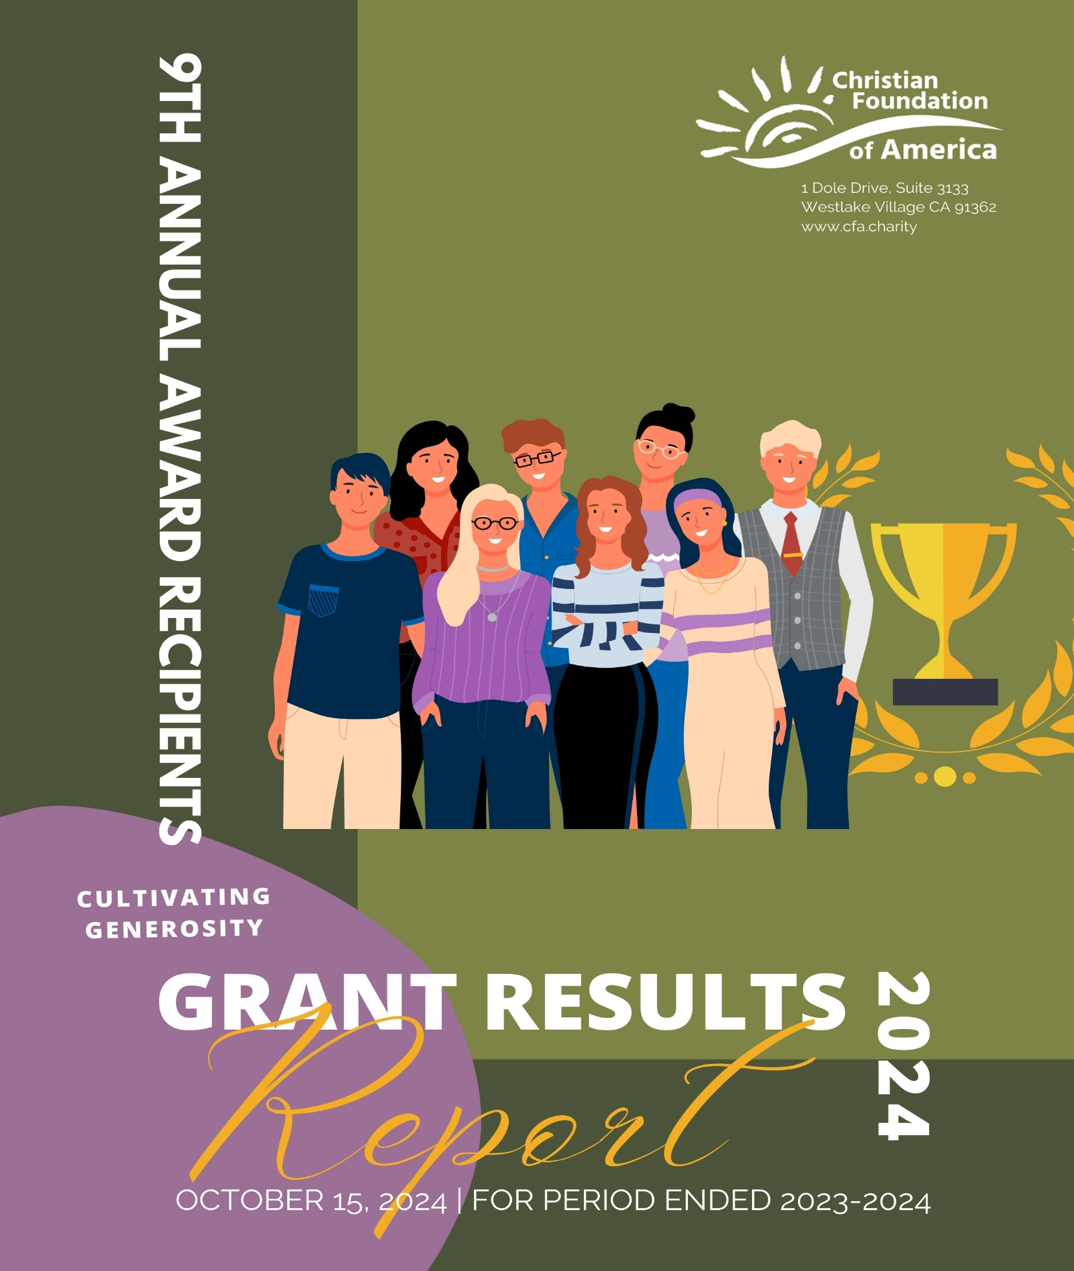

October 10, 2024

***Dear Donors, Grantees and Friends,***

We are so excited to share with you all of the amazing things God has done and is doing through the work of these Christian ministries over the past year. When we awarded $77,000 in grants to the 10 charities in March, we could only imagine the impact that would result.

We celebrated together on March 28, 2024 at our Award Banquet, each Ministry. Each ministry has prepared their reports as a “Thank You” and to let us all know what happened! There are moving stories and I hope you take the time to read each report! It’s a delight to present this report, and express for all of us gratitude to the Grantees for their dedication and service to the community.

We are inspired and grateful for the partnership of generous Donors and the amazing work by our Grantees! Thank you Donors! Your gifts have touched thousands locally and internationally as we continue to work together in our communities to deepen and grow these relationships, all for God's kingdom! I'm sure you will be moved, as we are, by the impactful work accomplished for Christian impact.

We are delighted to announce our **10th Annual** CFA Grant Program for 2024-25. We hope you will be part of this milestone year with us! The CFA Grants Committee has done an outstanding job each year selecting ministries doing amazing work, to advance the Kingdom. Your gifts make this possible and this year, our **TENTH YEAR** we hope to lift up in Praise God’s Blessings with the generosity of our entire community! We’ve set an audacious goal this year - $100,000. May God’s Blessings on each of our lives be inspiration to support some of the best Ministry Charities around, all to God’s glory!

Please make a generous gift. Gifts can be made in the following ways before January 31, 2025:

* Contribute online at [www.cfa.charity/grants-program/](http://www.cfa.charity/grants-program/) Click the "Give" button.
* By check (Made payable to CFA, Memo: Grant Fund) and Mail to:

1 Dole Drive, Suite 3133, Westlake Village, CA 91362

* Donor Advised Fund or Harvest Fund (if you have one or would like to open a DAF- email [Yolanda@cfa.charity](mailto:Yolanda@cfa.charity) )
* Gifts of Stocks, mutual funds, or other assets welcome! Please email [Yolanda@cfa.charity](mailto:Yolanda@cfa.charity) for details.

***We look forward to “Inspiring Generosity for Christian Impact” with you!***

Blessings,

**Katherine Saigeon**President and Director

Christian Foundation of America

[www.cfa.charity](http://www.cfa.charity)

***Contents***

***Grant Summary* 1**

***Exodus Vision* 2**

***Gti Hope* 4**

***James Storehouse* 8**

***Buyamba Uganda* 10**

***Community Pregnancy Clinic* 12**

***ReIgnite Hope* 14**

***Union Rescue Mission* 16**

***Before It Begins* 18**

***Communitas International* 20**

***New Challege Ministries, Inc.* 22**

**2024-25 “Cultivating Hope” 10th Anniversary Grants Program & Award Banquet 24**

# ***Grant Summary***

|  |  |  |
| --- | --- | --- |
| **Organization** | **Amount Awarded** | **Outcome** |
| Exodus Vision | $15,000.00 | Provided six pastor-training conferences.  443 pastors and church leaders received training! |
| Gti Hope | $12,000.00 | Sponsored 300 women in the literacy program to learn basic life and economic skills. Also, provided 10 sewing machines to impoverished women to improve life for their families. |
| James Storehouse | $10,000.00 | Funded RelateStrong Program to provide free mental health and well-being services to foster youth and aged out youth. |
| Buyamba Uganda | $6,250.00 | Sponsored 14 female university and trade school candidates with college studies and trade programs. |
| Community Pregnancy Clinic | $6,250.00 | Provided training to Registered Nurses in Limited Obstetrical Ultrasounds. |
| ReIgnite Hope | $6,250.00 | Provided partial scholarships to train 16 underserved individuals in welding skills for Mobile Welding Training and American Welding Society Certification. |
| Union Rescue Mission | $6,250.00 | Provided transitional housing for families in South Los Angeles at the Hope Gardens Family Center |
| Before It Begins | $4,500.00 | Provided education to promote purity within churches by equipping leaders to protect and restore the church from pornography, gender confusion for children. |
| Communitas International | $4,500.00 | Provided training for new church plants and missional communities into Ukraine/border cities of Russia. |
| New Challege Ministries, Inc. | $4,500.00 | Supported the food bank by covering operating expenses and provided maintenance/repairs on the delivery vehicle. |

# ***Exodus Vision***

Executive Summary of the Pastor Training Conferences Funded

by a Grant from CFA to Exodus Vision

SEPTEMBER, 2024

We, the board of Exodus Vision, would like to thank Christian Foundation of America for your generous grant of $16,000 awarded to us in March of this year. We were able to pay for all of five pastor-training conferences and 65% of a sixth one with this money. In these conferences we received reports that 443 pastors and church leaders received training of at least three Exodus Vision courses.

Our training conferences are organized in seven modules of three courses each. Each conference was organized and conducted by one of our six lead pastors. The pastors who led these conferences were all native Malawians. After they attended conferences that our Exodus Vision teams from the US conducted over several years, these pastors are now conducting these same training conferences on their own. Exodus Vision provides the funds for these conferences with these pastors providing the leadership and the actual training.

In each conference some of those who attended were given Bibles in their language. Many pastors in the rural areas of Malawi and Mozambique either do not have a Bible from which to preach or have church leaders who also don’t. We have a policy to provide $300 specifically designated for Bibles for each conference we fund.

Following are some brief details of each of the six conferences that you funded :

1. Held in the border town of Zobue, Mozambique, the first conference was hosted by a Mozambican pastor from a Baptist denomination in a church hall provided by a Nazarene church. This 4-day conference brought together 60 leaders and pastors from 14 different denominations. The conference was held in late April, 2024. Our lead pastor for this conference was Pastor Charles Tembo who was assisted by three other trainers who traveled with him to Zobue

In this very rural area of Mozambique, Pastor Charles reported that, “one out of ten believers, including pastors, use or consult traditional witch doctors for healing.” He reported that “we spent a substantial chunk of our time praying for the sick” and for freedom from demonic bondage. “A good number of them received Christ for the first time after hearing a clear presentation of the Gospel.” This was a Module One conference which teaches the three courses of “Salvation”, “Bible Study Methods” and “The Rooted Disciple.”

At the conclusion of the conference Pastor Charles reported that he challenged those in attendance, based on Joshua 24:14, to decide that day how they would choose to serve God, either according to the Scriptures or to continue in the “way they were doing before.” He charged them to “turn away from syncretism, idolatry and to fully devote themselves to God who is holy.” He said that as he was “leading them in a prayer of repentance and rededication, the (Holy) Spirit just took over…One could sense a revival breaking through their religious walls.” As they were leaving the conference, a common statement spoken to members of Pastor Charles’ team was, “Please come back soon. We want more of this teaching.”

1. The same week a second conference was conducted in central Malawi in the town of Kasungu. This was led by Pastor Ernest Chigawa who has just begun leading conferences after serving alongside Pastor Moses Nkhata for several years. This conference again had 60 pastors — 57 Malawian pastors and three from Zambia. In the area of Zambia that borders Malawi near Kasungu, many people speak the Chichewa language of Malawi. Pastor Ernest listed six denominations that attended and said there were several others. This was the fourth pastor-training conference that Pastor Ernest has held with this group of pastors. (Module 4 out of 7 modules.) Again, this was a 4-day conference.
2. The third conference that was funded by CFA funds was held in Mchinji district in the central part of Malawi. It was given to 60 pastors and church leaders who have churches in the rural areas of this region. This was their first Exodus Vision conference, receiving the training from our three courses in Module One. This was a 5-day conference with our lead pastor, Pastor Moses Nkhata, in charge of the training. It began on May 6th of this year.

In his introduction to his report from this conference Pastor Moses stated, “The root cause…of heretical teachings (in Christian churches) in rural Malawi and Mozambique” is that men declare themselves to be pastors even though they have not received Biblical training. They “create doctrines that suit their desires and heart…and are (often) in conflict with the Biblical doctrines.” He said this has been the case for decades in these rural churches and that the Exodus Vision ministry “has helped to fill the gap…by bringing training to the church leaders who are theologically illiterate.”

1. The next week, starting on May 13th, Pastor Moses hosted a conference in Northern Malawi in Mzimba, Edingeni district. In this conference Moses reported that 73 pastors and church leaders attended this 5-day conference. This area is considered by Exodus Vision to be far enough north that the conference was afforded an additional $700 for additional costs incurred by the team of teachers representing us. Pastor Moses is our lead pastor who has introduced our training conferences in this northern region.

In his report he described this area of Malawi as being mostly from the Ngoni and Tumbuka tribes, compared to the Chewa tribe that is strong in the central and southern regions of the country. The Christian culture in this northern area has many who practice polygamy, with many pastors also having multiple wives. Our team from the US has conducted three conferences in the north starting in 2019 and continuing in 2022. These pastors are very open to learning the teachings of Scriptures regarding marriage and church leadership. Our experience in teaching pastors in this area is that they are very teachable, approaching our training sessions with a humble attitude.

One of the challenges they faced in conducting this conference was that many of the pastors attending the training had to walk long distances to come. Both the Mchinji conference and the Mzimba conference are in mountainous areas and those walking to the conferences had to walk through these mountains to arrive at the conference. This willingness to walk long distances to be trained is a testament to their desire to be trained by our leaders using our materials.

1. Starting May 29th, a conference was held in Murumbu district in Mozambique. This was a 3-day conference reaching 70 pastors and church leaders and was hosted by our lead pastor, Evance Nauliya. Five of our courses were taught at this conference, including a course on Spiritual Warfare and a course taught to women entitled “Women in the Bible.” Pastor Evance’s wife, Liza Nauliya, taught this course to the women.

In his report written at the conclusion of the conference Pastor Evance provided us feedback from one of the pastors, Izeki Kuthebwe. “Most of us here in Mozambique who are pastors…have two wives, some believe in witch doctors and others abuse their wives causing their wives to “live in fear in their marriages.” He went on to say, “Before we go to teach others, we are supposed to change, because we learned here to teach others through our behaviors, not just to be good speakers. Thank you very much Exodus Vision because you have come here (at) the right time. Mozambique needs to be transformed by the true word of God like this.”

Another group of five pastors from an area distant from Murumbu said, “Pastors need these kinds of teachings. We are indeed very far from the truth. We have many evil activities here in Mozambique, though we are called pastors and Christian leaders. We need Christian Ethics teachings, so that we can understand the Christian rules to be followed by the believers, because if one is born again, he must live the Christian culture, not the traditional culture.”

1. The last conference receiving CFA funding was one held in Bangula, in southern Malawi. This 3-day conference began on May 23rd and had 120 pastors and leaders in attendance and was hosted by Pastor Charles Tembo. Since they had only planned for 80 to 100 pastors, they had to reduce the amount of food they gave to each attendee and didn’t have enough of the conference outlines to give to all who attended. But Pastor Charles said that they couldn’t bring themselves to turn away people who came and wanted to receive training.

This conference was taught by Pastor Charles and his team who helps him conduct the training. It was also a Module One conference reaching pastors from 35 denominations. $1,750 of the $2,700 that we sent came from the remaining funds from our CFA grant. The remainder of the funds came from our regular budget.

One of the men who attended the conference, Pastor Josephy Alufaneti, commented, “I have committed myself to go back to teach in nearby and far (away) communities. (We will) make small newlife groups so (that) we can reach the multitudes, preaching both in my church and to other communities

What a privilege it is for us to read the reports provided by our lead pastors after their conferences. Our God is using these men and these courses to bring a new level of maturity to the leaders of many churches in these rural areas of southern Africa. It’s exciting to think about the many members of these churches who are receiving Bible teaching at a new, more correct level from their pastors and church leaders.

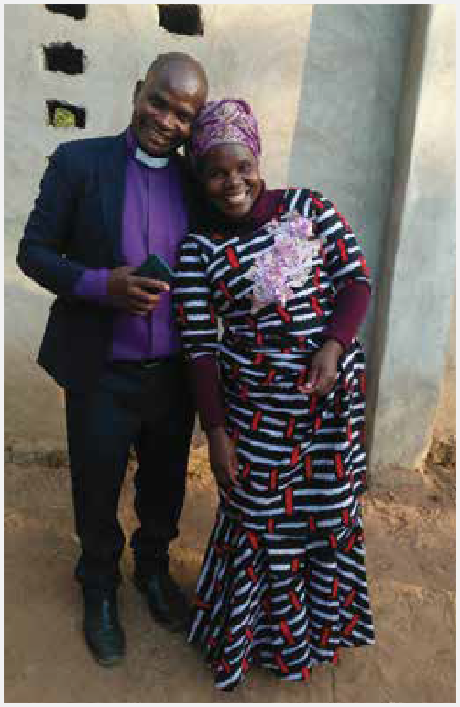Thank you, CFA, for catching our vision for training pastors in rural, southern Africa. It has been a privilege to team with you this year and we are hopeful that we can work together again in future years.

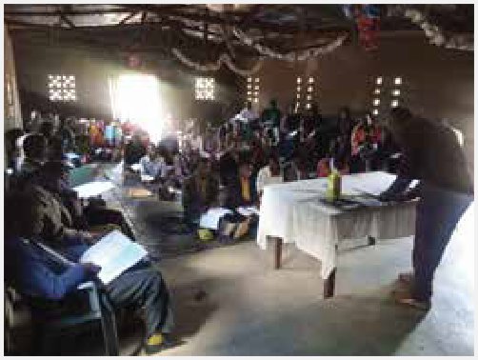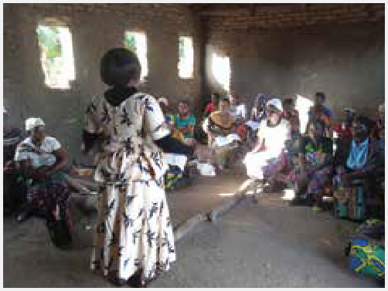

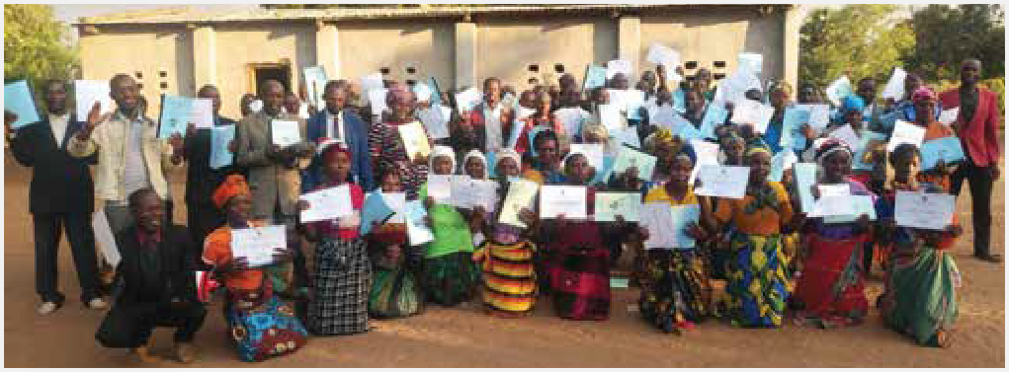

# ***Gti Hope***

*Byron Hack*

*President*

*981 W Arrow Highway #348*

*San Dimas, CA 91773*

[*byron@gtihope.org*](mailto:byron@gtihope.org)

**Women’s Literacy 5-month Report for Christian Foundation of America**

Dear friends at Christian Foundation of America,

We are pleased to provide the 5-month progress report for the 10-month literacy program for the **Kondha Soura Pana** Women’s Literacy project you are helping to sponsor through a portion of your 2023 mission gift. Thank you for your generous support which is sponsoring 300 women in the program.

The Women’s Literacy Program provides a 10-month Bible based literacy program for women from the Kondha, Soura, and Pana Tribal communities in Odisha, India. This report presents a summary of highlights and testimonies from individual learners for this project which started in April 2024 with 15 classes of 30 students in 15 villages. Your support is sponsoring 10 of these classes and impacting 10 villages. The raw data for the Adult Literacy Fifth Month report for each set of the 5 classes is available in separate documents upon request.

A portion of your gift sponsored 10 sewing machines for students from this literacy project who have been selected, based on need. The recipients have been chosen and we are enclosing photos of them. When the recipients receive their machines, you will receive a report with details about the individual women.

**Literacy Progress Report Highlights:**

**450** uneducated and unreached women who matter to God are being blessed with the light of literacy and the Gospel. They are learning skills which will make them less vulnerable to poverty, disease, abuse, child labor, indentured servitude, alcoholism and suicide. For the first time they are learning about Jesus and a God who loves them.

These women, including **49** children aged 12 to 14, are making great progress through the literacy program. It is encouraging that half way through the program, 100% of the students are still enrolled in the classes. *$7,500 of your gift is sponsoring* ***300******women***. Already, in the two projects you are sponsoring:

* 238 are considered to be average or fluent readers,
* 242 are considered to be average or excellent at math,
* 52 are earning more income,
* 45 have started savings,
* 55 are considered to be seekers, showing an interest in learning more about Jesus and perhaps accepting Him as their Lord and Savior,

The 5-month literacy reports are provided by the project officers. Each project officer supervises the teachers for the 5 classes of 30 students. They visit each class once per week.

**Evaluation of the First 5 Month’s Work Reported by Project Officers:**

* The women from the communities are now aware of the importance of education.
* In spite of the challenges, centers are running well and learners are attending class regularly.

This project is now in the homestretch of the literacy program.

Please pray for

* the safety and protection of the students, teachers, and Project Officers, especially in areas where persecution and harassment are prevalent.
* the Lord to open ears and hearts as the students continue to learn about the love of Jesus and the plan of salvation.
* the home fellowships that are beginning to form and for students with a love for the Word of God to step up as leaders of the groups.
* the people becoming educated to take leadership roles in their communities and transform families and communities for His glory.

**Summary of 300 students’ achievements after 5 months of Bible-based literacy classes:**

* 48 students able to comprehend newspapers
* 29 students able to read signboards and bus schedules
* 49 students report improved family relations
* 82 students have made behavioral changes and are giving up bad habits
* 92 students are aware of health hazards and improving their surroundings
* 260 students are giving up their superstitious beliefs

Students’ progress:

* 155 using Book 1 Primer
* 83 using Book 2 Primer
* 62 using Book 3 Primer

Fluency in Basic Math understanding

* Poor: 67
* Average: 132
* Excellent: 101

We look forward to sharing the final report with you in the coming months.

Peace and Blessings,

Byron Hack

President, GTi HOPE

Romans 10:13-15

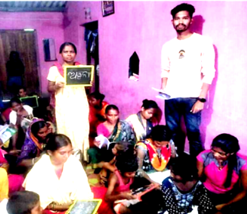***Literacy Brings Change for Anjana and Hemngini***

**Mrs. Anjana Bag**, her husband, Laxman, and their three daughters live in a small house in Litiguda Village. Their home is poorly maintained and they have no bathroom or toilet in their house. Anjana and Laxman both work as day laborers, earning daily wages when they can get jobs. Laxman is addicted to alcohol and wastes his money on this habit so that sometimes there is not enough money to provide food for the family.

Anjana was completely illiterate when she joined the Adult Literacy class, and admitted that she felt ignorant and did not know how to take care of the family. Now, after 5 months in the program, she is able to read the primers, is able to count the numbers, and has learned lessons about maintaining her house and family. She is requesting prayer for her husband, that he would change and leave all of his bad habits.

**Mrs. Hemngini Tandi** is married with two children. She and her husband both work as daily laborers. They live in a small hut without electricity, and without a bathroom or toilets. Prior to the literacy program starting in their village, they were living in complete poverty. They spent all that they earned, did not have any savings, and could not even afford healthy food.

Hemngini joined the class, and very soon was able to read from the primers and learned to do addition and subtraction. She also began to keep herself clean, as well as cleaning her house and surroundings. She is sending her children to school and has started saving money at the Post Office for her children’s future. Literacy has brought great change to their lives!

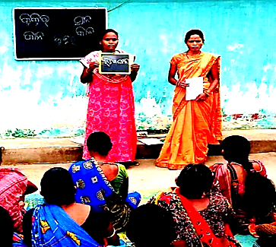

**Sewing Machine Proposal and Recipients**

Pastor Rajib Sipka is the project officer for the Adult Literacy Program. He has requested 10 sewing machines for some of the most vulnerable women attending the classes. He writes, *“These women are poor, [and doing] labor, agricultural seasonal labor, and migration labor. They are facing problems for food and they are also unable to get nutrition for their children due to lack of earning sources in their villages. If they can get [a] sewing machine, it will be a great blessing for their entire family. Thank you.”* Below are photos of the 10 recipients who will be given sewing machines through your support:

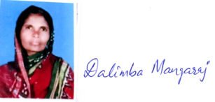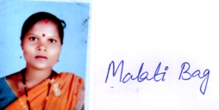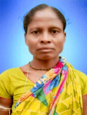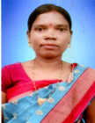

*Dalimba Mangaraj Malati Bag Sunita Bihari Madju Majhi Suaga Majhi*

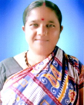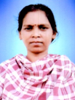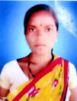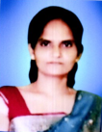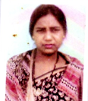

*Sarojini Majhi Rukmani Mangaraj Madjuri Bag Ruta Mangaraj Arati Bihari*

# ***James Storehouse***



October 2, 2024

Christian Foundation of America

1 Dole Drive, Suite 3133

Westlake Village, California 91362

Dear CFA Grant Team,

We sincerely appreciate your partnership with James Storehouse through your generous CFA grant. Your ongoing support for the vulnerable children and youth in the local foster care system means so much to us. Foster youth and aged out youth typically do not have equal access to mental health and well-being care and services due to the socioeconomic factors they face. With this year’s CFA grant, we were able to focus on our mental health and well-being program known as RelateStrong, which provides free services to the youth we serve at James Storehouse. This grant allowed us to accomplish our primary goals for this particular program.

We’d like to give you some updates and facts to show how your strategic partnership impacted our foster community since the grant.

**Program Updates:**

• As a certified and insured practicum site for the RelateStrong program — a framework grounded in theology and the best of psychology that provides emotion regulation skills and other tools for healthy relating — we are able to have Marriage and Family Therapy (MFT) graduate students on site at James Storehouse on a weekly basis. We have partnered with The Boone Center for the Family at Pepperdine University and their supervised MFT graduate students have been providing youth with free counseling services on a consistent basis. It has been an incredible experience to witness the healing that is happening in our youth and families.

• Our Youth and Family Center opened in February of this year, and one of the main features is our trauma-informed, developmentally appropriate sensory gym for smaller youth. We also have a private office space that is used for one-on-one therapy sessions with our on-site grad students — both in person and over Zoom. Additional features of our Youth and Family Center include our teaching kitchen and our rec area that our therapist interns use for individual and group sessions.

**How the Grant Was Utilized:**

• Funding was used for a HIPAA-compliant practice management system in order to enhance and protect the privacy of our clients. Our therapist interns use this software to take notes during sessions, keep clients’ information, fill out paperwork,

and give assessments for anxiety and depression. The supervising professor from Pepperdine University, Dr. DeeDee Mayer, also uses the software during her in-person supervision to help our therapist interns with their clients.

• Your grant was able to help purchase food items used during group therapy sessions with transitional age foster youth and trafficking survivors in addition to pregnant and parenting teens. Also, food was provided for parents and their children during court ordered visitations, as well as for life skills classes for transitional age foster youth. We have found providing food during sessions is a great way to help our youth relax and engage.

• We began our equine therapy program! Equine Therapy, also known as Equine-Assisted Therapy, is an innovative, experiential approach that actively involves horses in mental health treatment. A powerful, evidence-based modality, Equine-Assisted Therapy is also referred to as equine therapy, horse therapy, therapeutic riding, and equestrian therapy. Through horse-based activities, our former foster youth, aged out youth, teen parents and their little ones gain confidence, build trust, and form healthier boundaries. Moreover, learning how to work with and take care of a horse, with the guidance of an equine therapist, helps our youth practice empathy and develop authentic connections. This form of therapy is particularly effective for teens because it allows them to address emotions and issues through direct experience and nonverbal communication. Consequently, it can be especially helpful for our foster teens who are resistant to talk therapy.

• The funds were able to support therapeutic tools utilized during play therapy during court ordered visitations for biological parent(s) and their child/children, in addition to our youth trafficking survivors. Items like swings, weighted vests, fidget toys, games, etc. have been very effective therapeutic tools.

• Many of our youth have been able to experience the love of Christ through individual and group sessions at our Youth and Family Center! This has led to an overall improvement in the mental health of these individuals. Evidence of this growth has been witnessed by a greater self-awareness, healthier emotional regulation, an increase in positive behaviors, and growth in interpersonal skills. They feel supported and have a greater sense of confidence to make positive changes in their lives. It has been miraculous to witness the healing happening!

Thank you for your generous partnership with James Storehouse. Your funding toward the RelateStrong program and provision of mental health services at no cost to these vulnerable youth in our community has made and will continue to make a positive difference in their lives. Without your support, we would not have been able to make as much of an impact for the Kingdom!

Sincerely,

Stacy DeWitt

Executive Director

James Storehouse

3543 Old Conejo Road #105

Newbury Park, CA 91320

[www.jamesstorehouse.org](http://www.jamesstorehouse.org)

# ***Buyamba Uganda***



September 2024

Dear Friends at CFA,

Buyamba Uganda was the proud recipient of a generous Christian Foundation Cultivating Generosity Grant for the 2023-2024 year. We were blessed with $6,250 to help support our female university and trade school candidates, who each needed this sponsorship. We cannot thank you enough for your generosity. Your support has been instrumental in keeping 14 of these girls in college-level classes this year, bridging the gap between the financial support needed for their programs and their sponsorship support.

These 14 women are finishing up their second or third year in various college degrees, such as Christian Ministries, Special Needs, Law, Business Education, Child Development, and Arts in Education. They are also trade school students studying Hairdressing, Cosmetology, Tourism and Travel Management, Hotel Management, and Fashion Design.

Waldda and Stella were two students who graduated this year in Hotel & Catering and Tourism and Travel. They are now ready to enter the job market, a testament to the transformative power of your support!

The completion of higher-level education for any student in Uganda is a life-changing ability that has a lasting impact. For a woman, this opportunity is particularly empowering. Often, their lives are shaped by a series of misfortunes that lead to early marriages for financial reasons or other hardships that force them to drop out of school. The chance to pursue a career is a significant opportunity for them, giving them the ability to make decisions for their future and break the cycle of hardship.

Christian Foundation of America has been a force behind getting the students of God Cares School into higher learning levels. Our program starts in the three-year-old baby class and ends with spiritual transformation and education victories. CFA has been part of that growth through our partnership for the past eight years; this year, 14 girls were given the blessing, and they are forever changed.

Thank YOU, CFA, and may God bless you.

Sincerely,



Julie Dimas

Executive Director

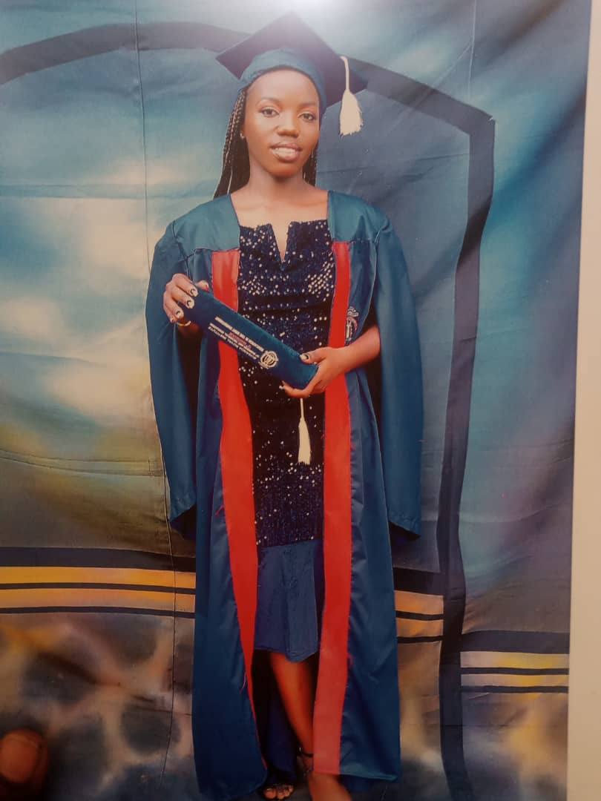 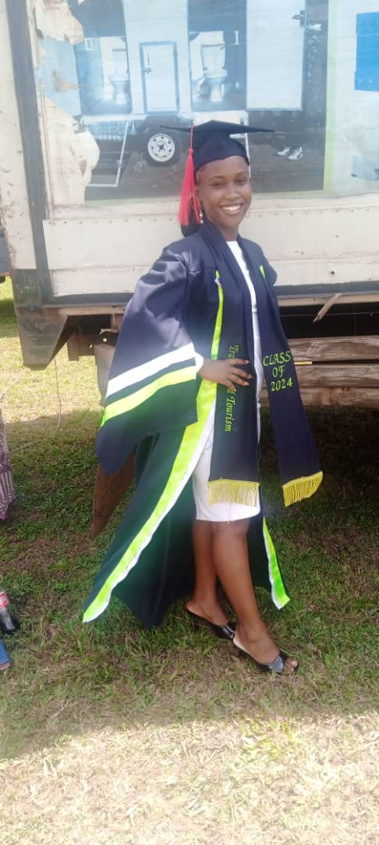

3625 E. Thousand Oaks, Blvd • Suite 265 • Westlake Village • CA 91362 • 805-558-0089 • Ugandabuyamba.com

# ***Community Pregnancy Clinic***

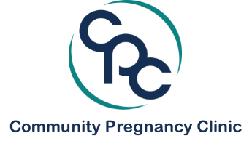

2045 Royal Ave., Suite 208 Simi Valley CA 93065 (805) 583-3598 [www.cpcsimi.org](http://www.cpcsimi.org)

October 2, 2024

Christian Foundation of America

1 Dole Drive, Suite 3133

Westlake Village, CA 91362

Dear Christian Foundation of America:

On behalf of the Community Pregnancy Clinic, we cannot thank you enough for the grant award of $6250.00 for the 2023-24 grant cycle.

From the time our grant proposal letter was written last year, we were able to use the funds for the following:

|  |  |
| --- | --- |
| **PROJECT/PROGRAM** | **OUTCOME** |
| **1. Training courses and conference for new Executive Director, Melissa Bokron:**  - Directors Institute of Pregnancy Clinic Management (NIFLA)  - Essentials in Client Marketing Course (Care-Net) for ED and Marketing Manager  - Leadership Summit* (California Alliance of Pregnancy Care)  - Abortion Recovery and Awareness Seminar (Care-Net) | Equipped our new ED in the essentials pertaining to policies, procedures and legal matters of a PHC; Pertinent information on how PHCs in the state of CA are uniquely impacted; marketing and communication to two unique demographics, clients and donors. |
| **2. Training in Limited Obstetric Ultrasound for two nursing candidates, resulting in one hire:** | Tiffany Taylor, RN, joined the staff of the CPC on September 9, 2024 |
| **3. Continuing education for our Nurse Manager, Susan Jones, RN** | Training complete for new Mindray DC70 ultrasound machine (granted via PreBorn!) |
| **4. Created and produced a 4-minute film “**[**Haven of Hope**](https://vimeo.com/1010357654)**”, highlighting the ministry, mission, and vision of the Community Pregnancy Clinic.** | Will be featured at all CPC fundraising events, speaking engagements, and donor communications. |
| *\* NIFLA National Conference and Training postponed until March 2025* | Nurse manager went out on 8-week medical leave and could not attend. ED attended CAPC summit in its place. |

Again, we are humbled and filled with gratitude that we were recipients of this grant award. As we look to the 2024-25 cycle, we have so many new and exciting things to report! We will most definitely be applying for the 2025 grant.

Blessings to you,

Melissa Bokron

Executive Director

Community Pregnancy Clinic

O: 805-583-3598 ext. 106

C: 805-390-2183

E: [melissa@cpcsimi.org](mailto:melissa@cpcsimi.org)

Below stats are from Oct 2023-Aug 2024 and were shared at our 34th Annual Benefit Dinner on 09/27/24:

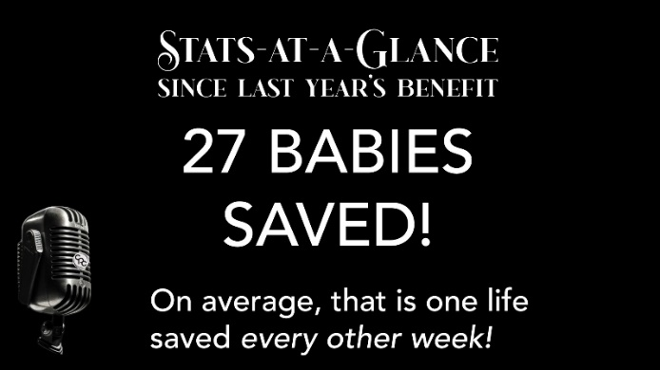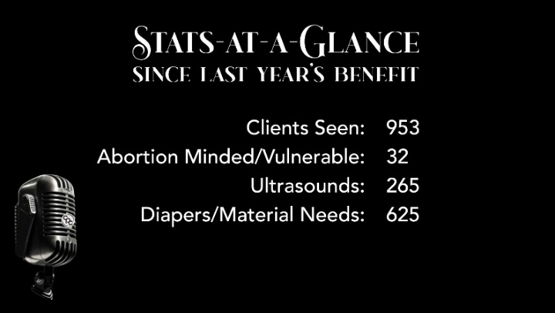

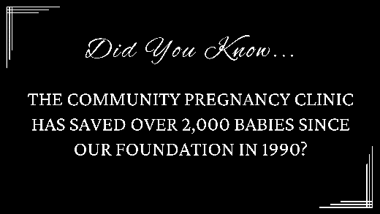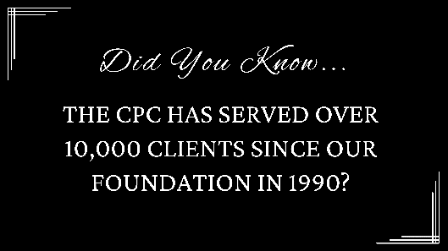

# ***ReIgnite Hope***

**RelGNITE**

14333 S. Figueroa St.• Gardena, CA • 90248 Phone: (310) 847-0593

**H@PE**

[www.reignitehoµe.com](http://www.reignitehoµe.com/)

October 4, 2024

**RE:** Christian Foundation of America Report for Program Year 2024

**Organization Name:** RelGNITE Hope

**Organization Project Name:** Mobile Welding Training and Certification Classes

**2024 Program Year Grant Description:** For this project, we proposed a partial scholarship to train 16 or more underserved individuals to become American Welding Society (A\NS) certified welders .i.n Re!GN!TE Hope's existing training centers including our three Mobile Welding Training Labs.

**2024 Program Year Grant Activities:** Classes were held at various churches in Program Year 2024 during the First Quarter of 2024 for 120 hours of instruction and welding practice as well as in life and work skills. The Gospel of Jesus Christ was integrated into all daily activities. At lunch each day, there was a testimony. Prayer was an integral part of all daily activities with prayer requests from students daily. The individuals we served during this grant were underserved populations with multiple barriers to employment; ~95% are impoverished; ~75% are minorities; and ~50% are justice-involved individuals.

Each student was taught about four types of welds (Mig, Tig, Flux, or Stick) and had a chance to train and practice to get AWS-Certified. Mig welding is for manufacturing; Tig welding is for aerospace; and, Stick and flux core welding are for construction.

Churches that hosted our Mobile Labs supported the classes with free parking, providing lunch, math tutoring, job placement, and facilities for eating lunch, classes, and mentorship with students.

Staff supported students with classroom activities, welding lab assistance, and student services including resume writing, interview prep, financial literacy, legal aid, and job placement. Through our vast network of community-based organizations, we referred students to resources for needs such as housing, food, transportation, and child care. We also taught about valuable work and life skills such as work ethic, respect, teachability, punctuality, and responsibility from a Biblical perspective.

**Progress and Outcomes:**

During Program Year 2024, we completed two classes in Gardena, CA, one in Rolling Hills Estates, CA at Rolling Hills Covenant Church, one in Lawndale, CA and Restoration Life Church, and one in San Pedro, CA at the USS Battleship Iowa.

**Total number of students trained:** We taught 125 students and graduated 112 of these students during Program Year 2024, of which 49 students graduated from Mobile Labs. This graduation rate from Mobile Labs far exceeded the proposed 16 students.

**Name of credentials earned:** For Program Year 2024, graduates earned one or two welding certificates from the American Welding Society in Mig for manufacturing, Tig for aerospace manufacturing, Stick for construction, and NR232 for construction.

**Number of credentials earned:** A total of 220 AWS welding certificates were earned by graduates for Program Year 2024, For the 220 graduates, all graduates received one AWS welding certificate and 218 graduates (99%) received two certificates. The breakdown of the specific AWS welding certificates is as follows:

|  |  |  |  |
| --- | --- | --- | --- |
| **MIG**  96 | **TIGSS**  54 | **Stick**  63 | **NR232**  7 |

**Jobs/Apprenticeships:** Between January and April 2024, we helped 73 past graduates obtain jobs or apprenticeships. This resulted in an overall 65% job placement rate for past graduates compared to the 112 graduates from the First Quarter of 2024.

**In Conclusion**

The welding training and certification program through RelGNITE Hope and partnership with Christian Foundation of America in Program Year 2024, has benefited numerous marginalized individuals from disadvantaged communities with high paying, sustainable welding jobs and more importantly Jesus. We know dozens of students have surrendered their lives to Jesus Christ and are on a path of hope and restoration,

Feel free to reach out to me with any questions you have.

Sincerely,

11

Sherrie Newton

Vice President of Operations 310.367.1731

& emait [sherrie@reignitehope.com](mailto:sherrie@reignitehope.com)

# ***Union Rescue Mission***



**Final Grant Report to The Christian Foundation of America**

**$6,250 Awarded FY2024 (2023-2024)**

**Organizational Contact**: Tim Peters, Director of Planned Giving. Email: tpeters@urm.org

**Project Name:** Hope Gardens Family Center – Transitional Housing for Women & Children

**Report Date**: October 1, 2024

This report outlines grant funding results at Hope Gardens Center as a result of the $6,250 grant awarded by The Christian Foundation of America in Fiscal Year 2024. Your continued partnership helped meet the costs of Hope Gardens Family Center, our comprehensive transitional housing program for women and children, single women, and senior women experiencing homelessness. These programs are only a handful of our programs that provide housing and Christ Centered recovery programs that fuel life transformation and end homelessness for families.

**1) Grant Usage**

Grant funds from The Christian Foundation of America were fully expended towards Hope Gardens Family Center operations, which helped end homelessness for 116 single moms and their children over the last year. As part of the program, mothers engage in hundreds of hours of case management, mental health counseling, Christian faith counseling, financial literacy, and life-skills classes—services that address the root causes of homelessness and provide practical help and support to forge the change that leads to long-term life transformation. Their children enrolled in school and participated in after-school programs and youth development activities to help address their socio-emotional needs. Together these programs change the trajectory of their lives and their children's lives, many of whom have never known the peace that comes from a stable and safe place to call home.

**2) Measured Outcomes on Grant-Related Activities**

Outcomes for Hope Gardens Family Center FY2024:

* Number of moms served: 116
* Number of children served: 162
* Number of families from Hope Gardens who transitioned into permanent housing: 62

By far the best way to measure outcomes is through changed lives. We have scores of stories showing how lives are transformed. Please take a moment to reflect on the inspiring story of Zulema, who had an addiction to alcohol and drugs and who became homeless. As a young woman living on the streets of Los Angeles, she had to do whatever she could to survive. She says, “While on the streets, I felt worthless. I didn’t think there was a way out.” When she found out she was pregnant, she didn’t want her child to be born on the streets and wanted a future for her child. Then, she came to Union Rescue Mission and enrolled in the recovery programs offered through Hope Gardens Family Center. Her life has since radically changed.

Last year, more than half the people we served were women and children. Across all programs, outcomes for our Women, Children, and Families programs in last fiscal year included:

* Number of women served across all programs: 1,747
* Number of single adult women served at Downtown URM: 242
* Number of moms served at Hope Gardens Family Center: 116
* Number of children served at Hope Gardens Family Center: 162
* Number of families served at Angeles House: 180
* Number of children served at Angeles House: 407
* Number of children served (across all programs): 1,541

For all populations we achieved the following service numbers across all programs:

* Number of nights of shelter provided: 484,315
* Number of meals served: 730,000
* Number of visits logged to the onsite medical/dental/mental health clinics: 8,000+
* Percentage of moms at Hope Gardens participating in case management: 100%
* Percentage of families transitioning from Hope Gardens into permanent housing: 85%

LEADERSHIP UPDATE: Mark Hood has been appointed as the new CEO of Union Rescue Mission and Richard Baker has been named President. Mark Hood succeeds the Reverend Andy Bales, who ministered to the homeless at URM for two decades before relocating to Iowa on December 31, 2023. Mark clearly understands the central role of evangelism, the innovative business experience needed to lead the Mission’s strategic development, and a deep commitment to sharing the Gospel. He also brings a wealth of experience leading, building, and motivating teams and a passion for positive change to URM. Mark's key focus will be establishing partnerships, strengthening relationships, driving growth, and sharing stories of transformation and the value of URM’s work in the community—made possible with support from donors and foundational partners. *The appointment of Mark Hood and the promotion of Richard Baker are crucial steps in ensuring that URM can meet the needs of our guests and broaden our impact in Los Angeles.*

**Conclusion**

Grant funding from The Christian Foundation of America has played a vital part in helping to provide pathways out of homelessness for 116 families at Hope Gardens over the last year. Stephanie is just one of these families in the last year that went through Hope Garden’s program. CFA has helped Stephanie and 115 other moms with hope and restoration. Please watch Stephanie’s story: <https://www.youtube.com/watch?v=GwOLkeLDiS0>

As the only mission of its kind serving women, children, and families on Skid Row, Union Rescue Mission is incredibly grateful for the consistent and faithful support we receive from CFA to fund these programs. Your support is vital in helping us change lives of women, children, and families living on the streets. For any further questions you may have, please contact Tim Peters, Director of Planned Giving, at [tpeters@urm.org](mailto:tpeters@urm.org)

545 S. San Pedro Street • Los Angeles, CA 90013 USA • 213-316-2742 • www.UnionRescueMission.org

# ***Before It Begins***

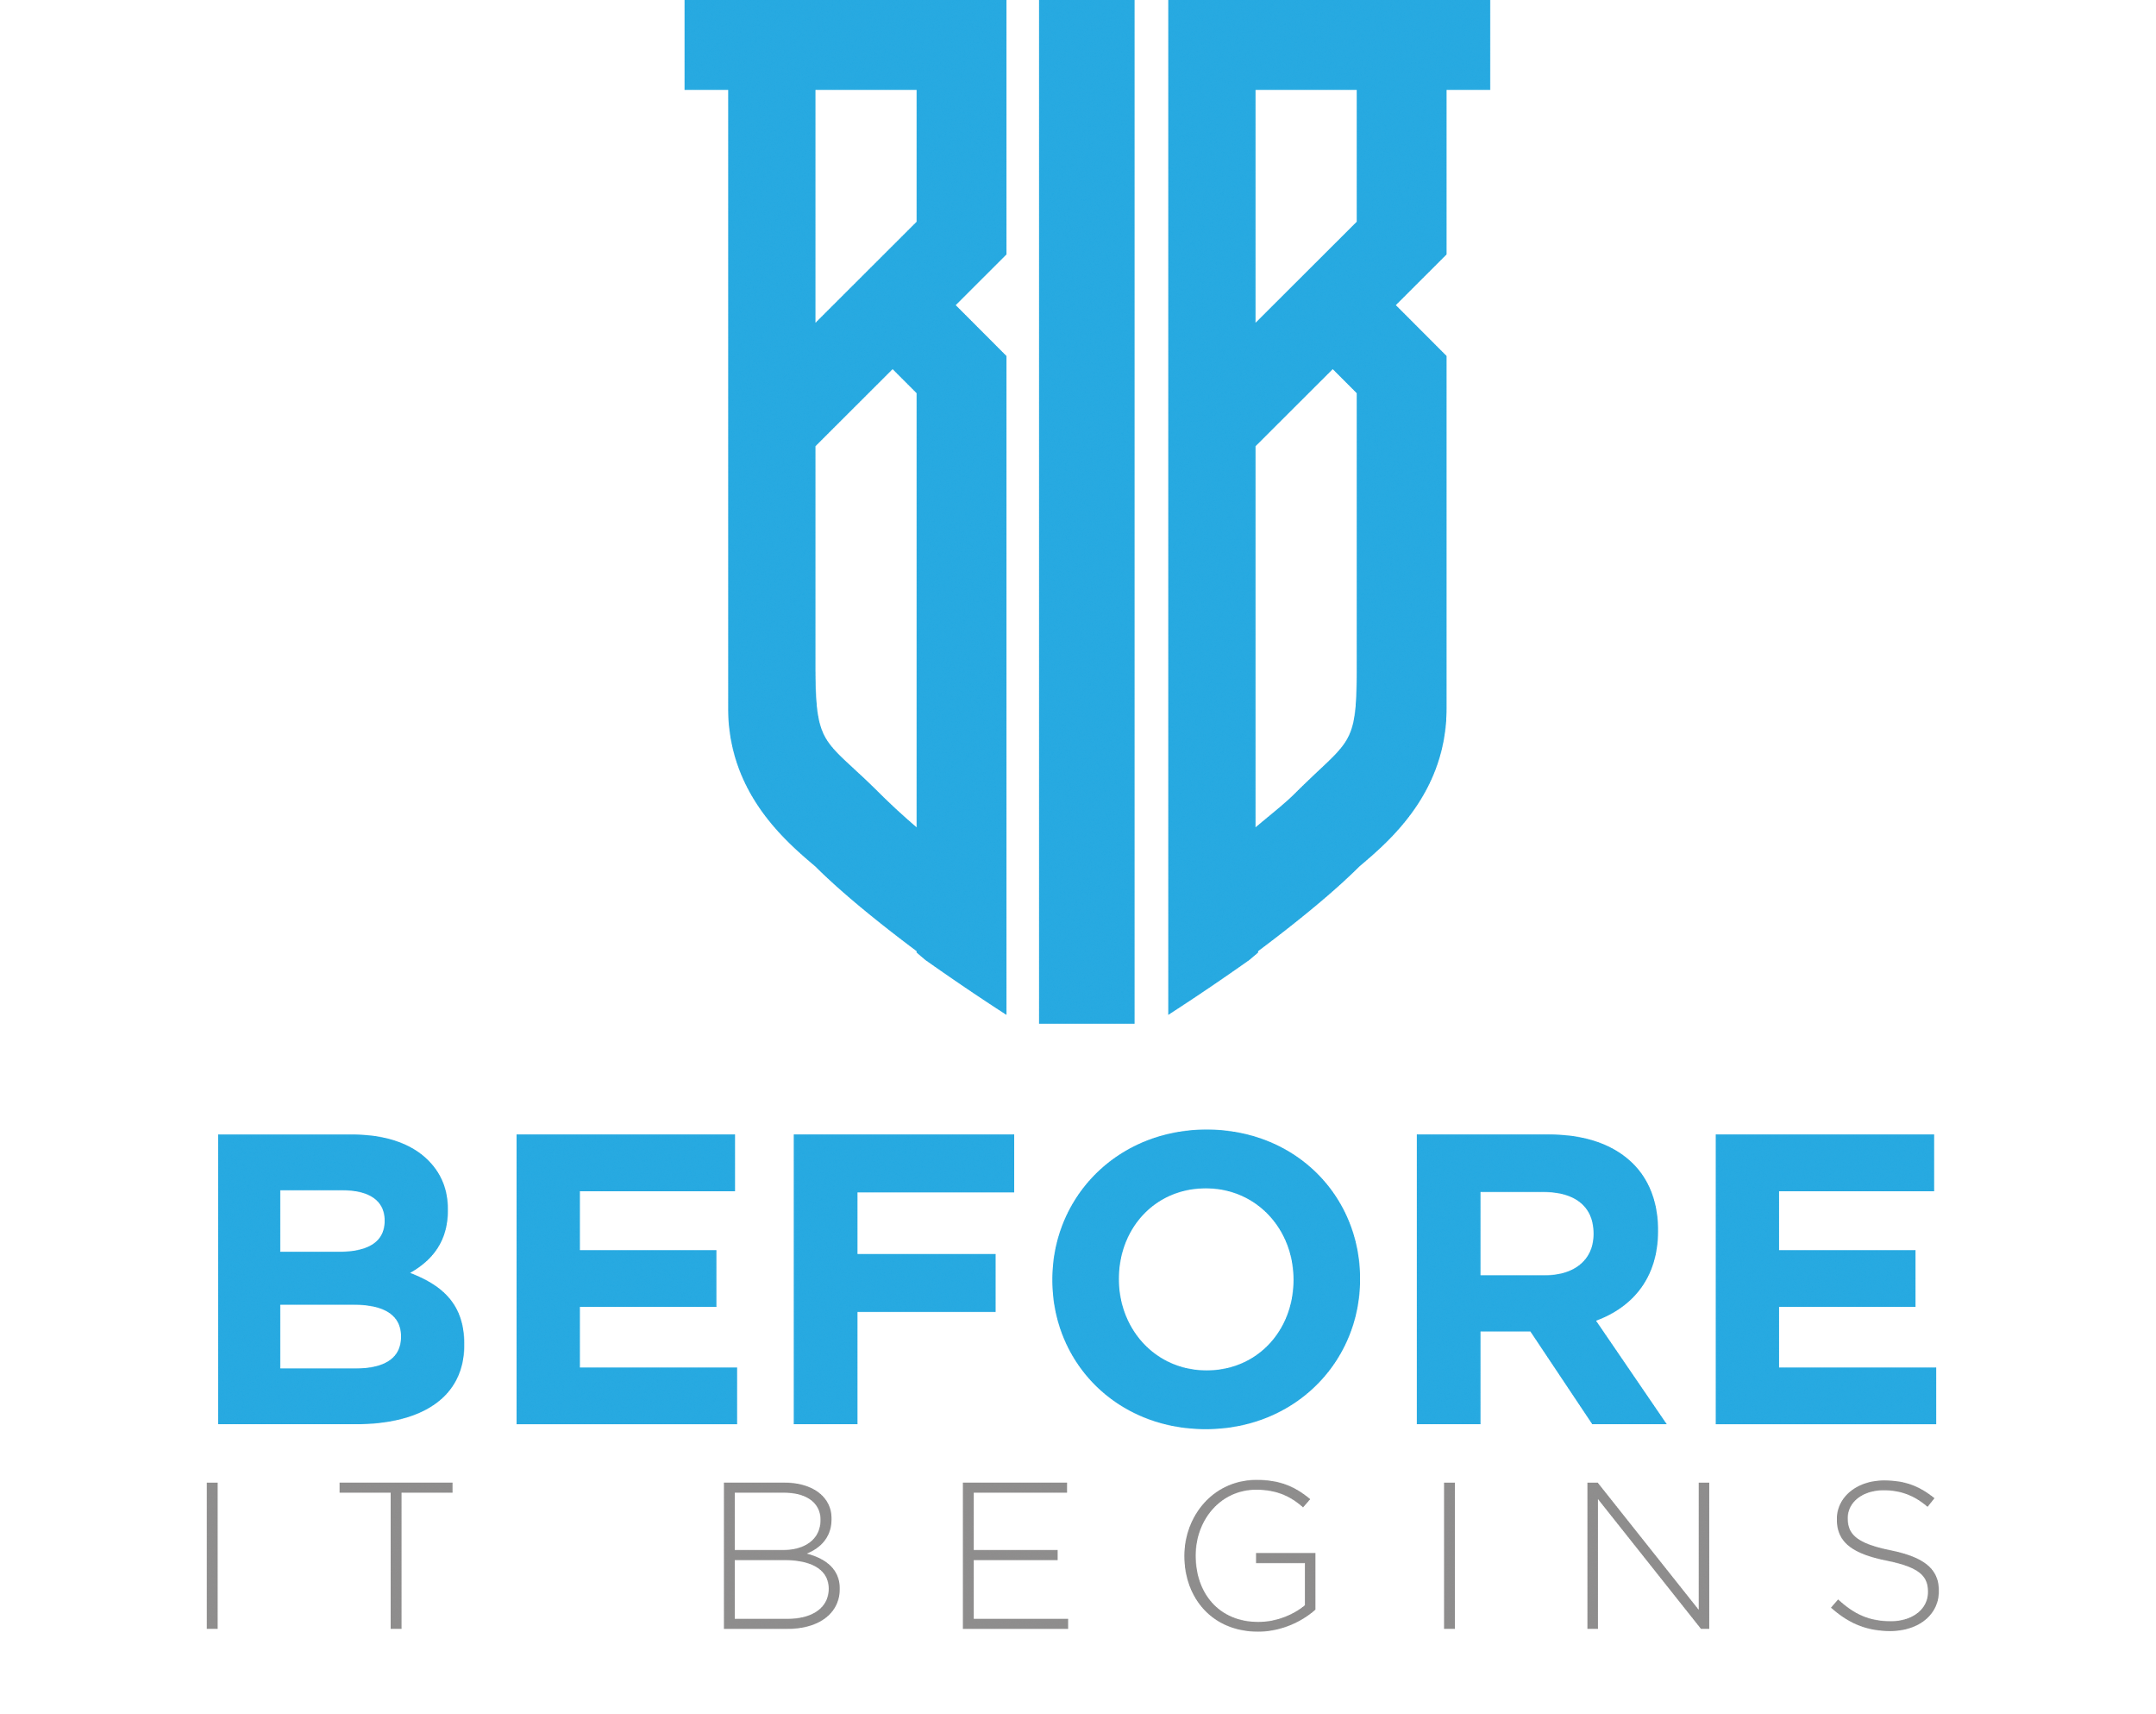

Being awarded a grant from Christian Foundation of America was one of Before It Begins’ greatest blessings and honors of 2024. On behalf of the pastors, parents, and children that we serve, we offer this performance report as a thank you to the Christian Foundation of America and its supporters and as a testimony to God’s goodness and faithfulness.

**The CFA Grant has produced measurable results this past year and is changing lives through our ministry!!!!**

**1. Saved over 1,000 children from oversexualization and gender confusion**

Our children are under attack like they’ve never been before through today’s unbiblical and destructive sexualization and LGBTQ ideology. Thanks to the CFA grant, Before It Begins was able to expand and update our content, promote, and execute a record amount of our Parent Workshops in 2024. These workshops helped equip Christian leaders and parents to disciple our children to grow up to be Godly men and women after God’s own heart and design for our identity.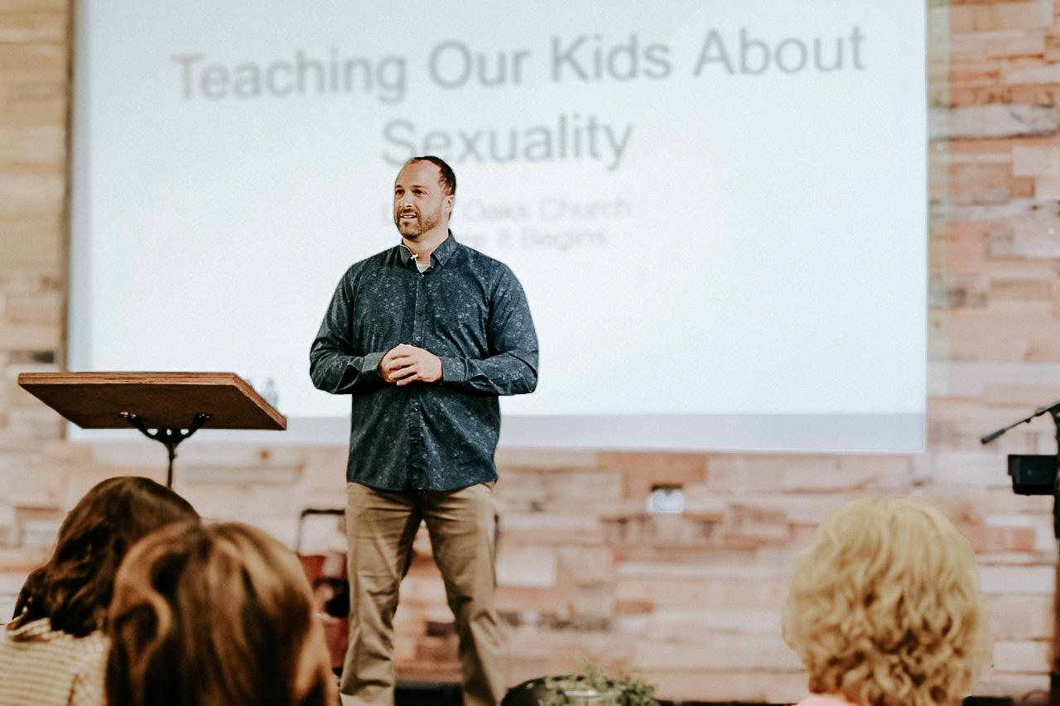

**2. Trained over 500 Chrisitians to evangelize a generation of youth with the beauty of God’s design for our sex and gender.**

Today’s youth have chosen the transgender topic to be one of their defining social issues and the church’s response to this will determine whether or not many will have anything to do with the church or even Jesus himself. Thanks to the CFA grant, Before It Begins was able to expand and update our content, promote, and execute a record amount of our RETURN of the Imago Dei (Image of God) events in 2024. These events equipped church leaders to effectively demonstrate truth in love so that we can win over the lost with the beauty of God’s design for our identity.

*“The Before It Begins team brought a lot of timely messages and really challenged us to think about how we present sexuality in our churches and homes”* -- Senior Pastor Dave Engle

**3. Rescued over 100 pastors from sexual sin**

We believe that all of us are regularly exposed to sexual images and temptation. . . few of us have a safe place to go to receive support. . . and none of us were meant to fight this fight alone. This is especially true for our pastors and ministry leaders who often experience more frequent attacks and typically have greater consequences for moral failure. A portion of the funds provided by the CFA grant were utilized to improve our training and overall care that we offer to pastors.

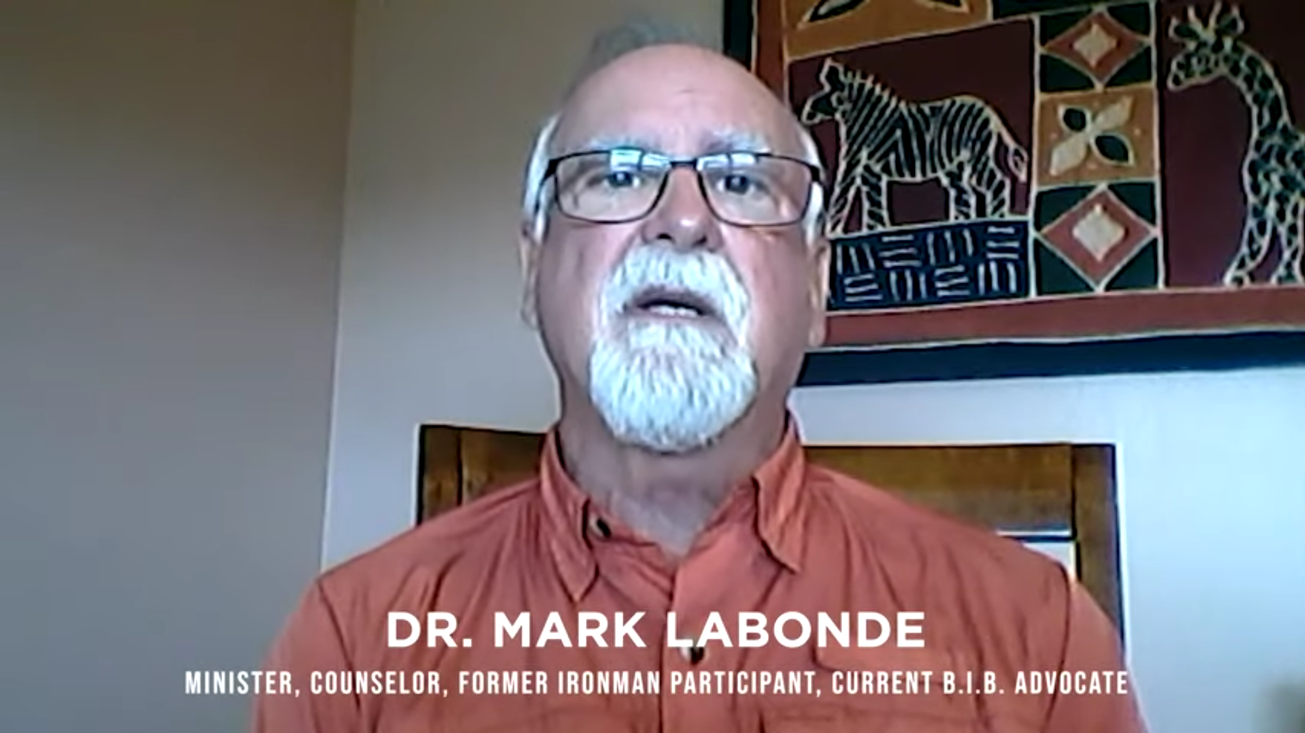

“As a pastor, there are very few safe places to talk about temptation. So to protect me and my family, I contacted Before It Begins. They provided me a safe place for accountability and friendship. It has been an extremely helpful experience.” -- Dr. Mark Labonde.

**4. Discipled over 500 Christians for greater intimacy with God**

Today’s pornography is pervasive and unlike anything ever seen before and few things threaten our personal holiness, identity, and calling like sexual sin. Thanks to the CFA grant, Before It Begins was able to expand and update our content, promote, and execute a record amount of our Protecting our Intimacy with God Workshops. These workshops train Christians to stand firm in the midst of sexual temptation and to restore the identity of those who are already in bondage to sexual sin.

**5. Expanded our services into an additional 600 churches worldwide!**

As a result of our increased promotion and marketing in 2024 (partially funded by our CFA grant), we were able to secure a new partnership agreement with a network of over 600 churches worldwide! As a result of your support, these 600 churches are now doing more than ever to protect and promote biblical sex and gender in their churches, families, and communities.



# ***Communitas International***

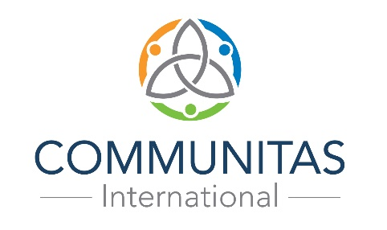

October 5, 2024

Dear Christian Foundation of America,

We are grateful for your generous investment into Communitas International Eastern & Central Europe. We have had a very successful year of developing and leading programs geared towards discipleship, leadership development and church planting.

The vision we had for using the funds given by CFA for 2024 was to help launch training and coaching ministry in Ukraine, Disputed Territories (between Russia and Ukraine) and new cities in Russia. We utilized some of the funds for planning to further develop new city networks in Russian cities of Krasnodar, Volgograd and Stavropol. Lastly, we desired to improve our newly launched online training website.

We are thrilled to share with you the following achievements…

* We assisted in the launching of 9 new churches. We hoped for more, however, the Ukraine/Russia war has somewhat slowed our efforts towards starting churches in some of the original planned cities. God is good and we see HIM leading us into planting more churches this next year. His timing is best!
* We launched 3 new network hubs as planned two in the cities of Volgograd and Krasnodar. We had hoped to launch one in Stavropol, but we ended up starting a needed hub in Donetsk Region of Russia. This hub will collaborate with leaders and churches both in Russia and the disputed territories of Russia/Ukraine as this city is right on the edge of the war zone.
* We were able to host several core trainings. We assisted in hosting an Alpha training conference, provided training for our Young Life members at their leadership conference and hosted a Gospel Foundations conference in two cities. We saw God exceed our plans and efforts with in-person training for 2024. We were able to train well over 300 leaders. The successes of these conferences has led to our launching a New Dynamic Adventure online training cohort as part of our long-term training vision.
* Our monthly online training and coaching Dynamic Adventure program continues to grow and develop. We hosted 17 online trainings this past year and have seen over 200 leaders go through our training and coaching cohorts. This resulted in reaching our goal of seeing new Missional Communities launched in 2024. We can track over 20 new communities launched. We believe more communities were launched but we are still waiting to hear back from a couple churches. Seeing these new communities launched is exciting because this is where we see traction for new churches being planted in the future. Praise God!
* One of the biggest surprises this year was the response to our new Training Platform we host it on a site called Podia. Podia is a professional training platform where we get to engineer our own training modules, homework and interactive message boards. We launched our platform one year ago with the hope of seeing 80-100 people become members joining the site. As of today, we have 447 members. We are seeing well over the 50% monthly usage we had desired. It’s just a wonderful way to deliver “just in time” training. CFW helped fund the launch in 2023 then you gave us funds for 2024 to improve the platform and the investment has exceeded all expectations.

Our hearts are full of joy and gratitude for CFW’s investment into the lives of leaders and emerging leaders in the countries of Russia, Ukraine, Poland, Belarus and war-torn disputed territories between Russia/Ukraine. God has and continues to bless us with multiply ways for our ministry to expand. Without CFW’s support it would not be possible to fully realize what God has called us to do. We praise God for the generous and obedient donors who give to further God’s Kingdom and hope you all know all our leaders are grateful and blessed.

If you would like more information or need additional details/stories in a different format, please do not hesitate to ask. We have so much to report! Praise God!



Blessings

Michael Katzenberger

Eastern & Central Europe Director

Communitas International

# ***New Challege Ministries, Inc.***

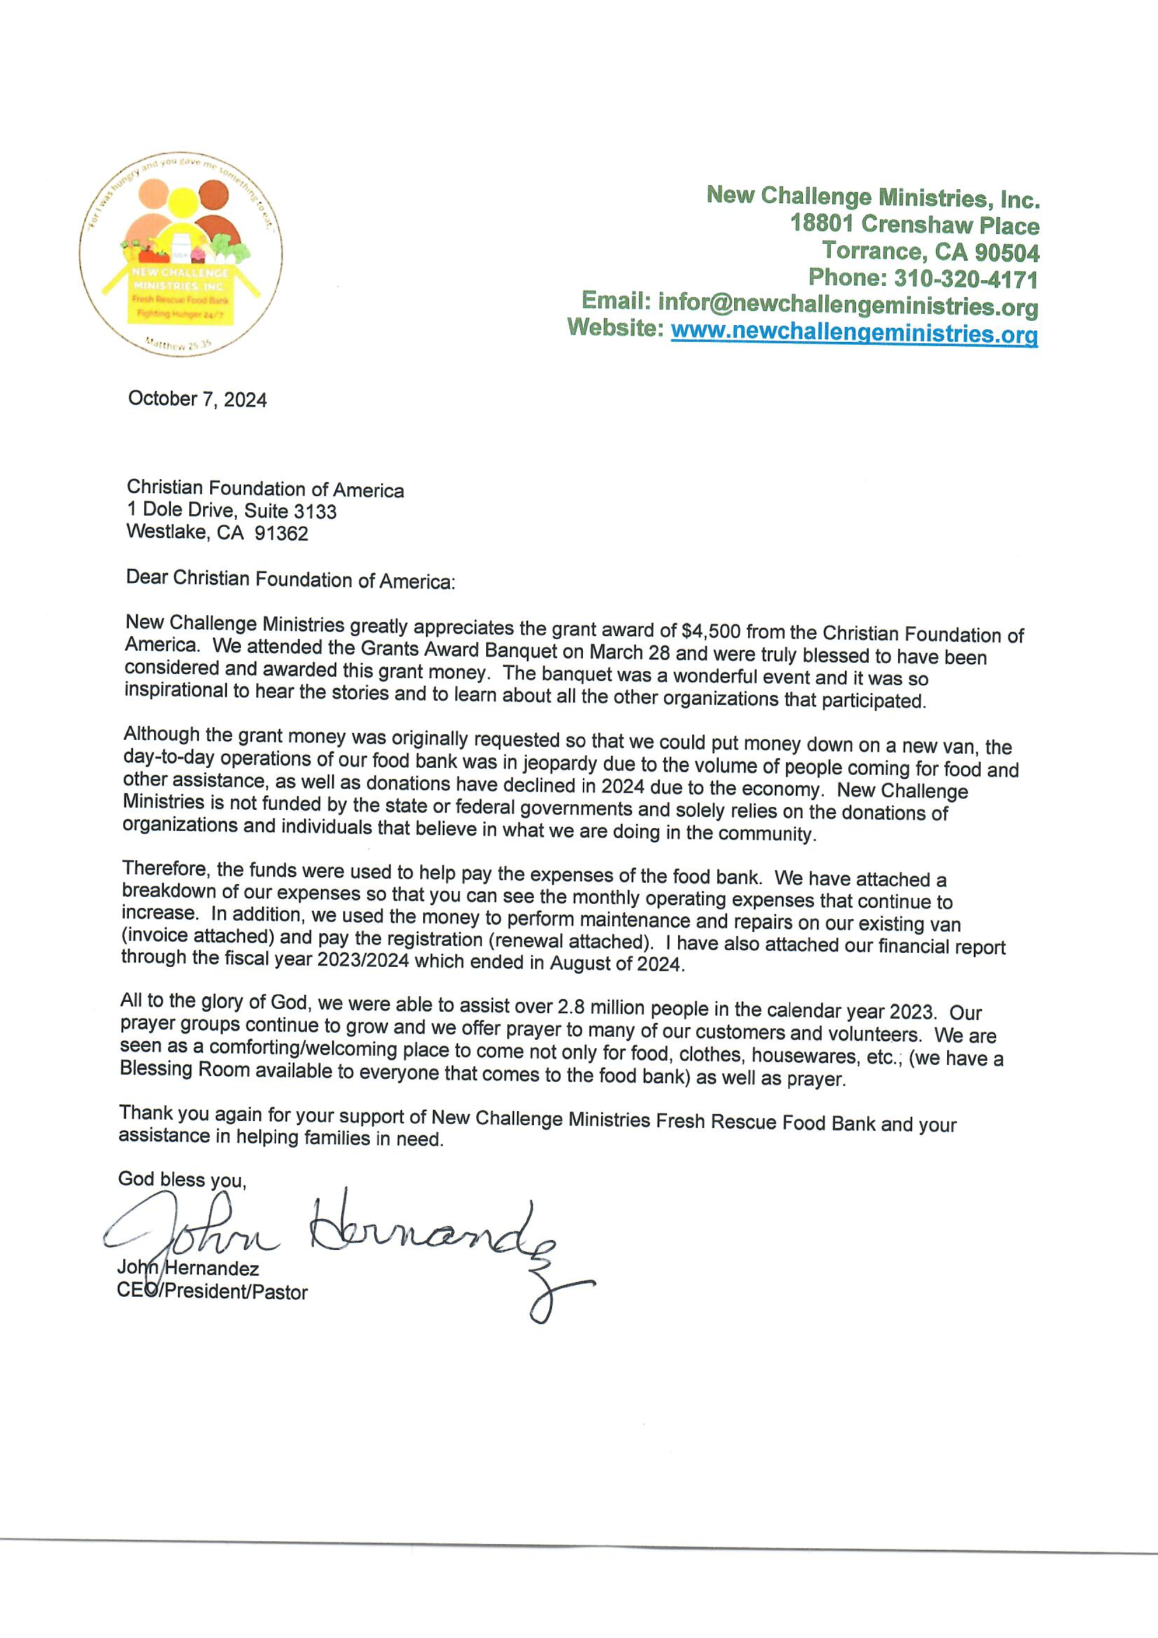

**New Challenge Ministries, Inc**.

18801 Crenshaw Place  
Torrance, CA 90504  
Phone: 310-320-4171  
Email: infor@newchallengeministries.org  
Website: [www.newchallengeministries.org](http://www.newchallengeministries.org)

October 7, 2024

Christian Foundation of America  
1 Dole Drive, Suite 3133  
Westlake, CA 91362

Dear Christian Foundation of America:

New Challenge Ministries greatly appreciates the grant award of $4,500 from the Christian Foundation of America. We attended the Grants Award Banquet on March 28 and were truly blessed to have been considered and awarded this grant money. The banquet was a wonderful event and it was so inspirational to hear the stories and to learn about all the other organizations that participated.

Although the grant money was originally requested so that we could put money down on a new van, the day-to-day operations of our food bank was in jeopardy due to the volume of people coming for food and other assistance, as well as donations have declined in 2024 due to the economy. New Challenge Ministries is not funded by the state or federal governments and solely relies on the donations of organizations and individuals that believe in what we are doing in the community.

Therefore, the funds were used to help pay the expenses of the food bank. We have attached a breakdown of our expenses so that you can see the monthly operating expenses that continue to increase. In addition, we used the money to perform maintenance and repairs on our existing van (invoice attached) and pay the registration (renewal attached). I have also attached our financial report through the fiscal year 2023/2024 which ended in August of 2024.

All to the glory of God, we were able to assist over 2.8 million people in the calendar year 2023. Our prayer groups continue to grow and we offer prayer to many of our customers and volunteers. We are seen as a comforting/welcoming place to come not only for food, clothes, housewares, etc.; (we have a Blessing Room available to everyone that comes to the food bank) as well as prayer.

Thank you again for your support of New Challenge Ministries Fresh Rescue Food Bank and your assistance in helping families in need.

God bless you,



# ***2024-25 “Cultivating Hope” 10th Anniversary Grants Program & Award Banquet***

Join us as we *Inspire Generosity* with a goal of $100,000+ to invest in Kingdom building charities and ministries. Your gifts make this unique program possible to encourage creative projects led by organizations within our communities. Our past donors have remarked at the outstanding quality of charities selected for grants, and their ability to meet and support multiple ministries serving some of the most vulnerable among us.

**HERE’S HOW TO DONATE TO THE GRANT FUND:**

* **Online -** (Go to: <https://cfa.charity/grants-program/> )
* **By Check -** (Make check payable to: Christian Foundation of America,

Memo line: Grant Fund

and mail to: 1 Dole Drive, Suite 3133, Westlake Village, CA 91362)

* **Donor Advised Fund -** (If you have one or would like to open one – email [yolanda@cfa.charity](mailto:yolanda@cfa.charity) with instructions)

**Celebration Awards Banquet**

**On March 27, 2025**

**North Ranch Country Club**

Stay tuned for all the details on our website:

**Website:** [**https://cfa.charity/grants-program/**](https://cfa.charity/grants-program/)

**Questions**: Call or email us at:

805-523-9087 / [info@cfa.charity](mailto:info@cfa.charity)

